Project Planning Phase

**Project Planning Template (Product Backlog, Sprint Planning, Stories, Story points)**

|  |  |
| --- | --- |
| Date | 18 October 2022 |
| Team ID | PNT2022TMID18497 |
| Project Name | Project -IoT Enabled Smart farming  Applications |
| Maximum Marks | 8 Marks |

Product Backlog, Sprint Schedule, and Estimation (4 Marks)

Use the below template to create product backlog and sprint schedule

|  |  |  |  |  |  |  |
| --- | --- | --- | --- | --- | --- | --- |
| **Sprint** | **Functional Requirement (Epic)** | **User Story Number** | **User Story / Task** | **Story Points** | **Priority** | **Team Members** |
| Sprint-1 | Registration | USN-1 | As a user, I can register for the application by entering my Gmail, email then you can received the OTP or Verification Code. | 2 | High | Rupadarsini  Roshni  Pavya  Nisha |
| Sprint-1 |  | USN-2 | As a user, I will receive confirmation Gmail or email once I have registered for the application. | 1 | High | Rupadarsini  Roshni  Pavya  Nisha |
| Sprint-2 |  | USN-3 | As a user, I can register for the application through Gmail and phone number. | 2 | Low | Rupadarsini  Roshni  Pavya  Nisha |
| Sprint-1 |  | USN-4 | As a user, I can register for the application through Gmail | 2 | Medium | Rupadarsini  Roshni  Pavya  Nisha |
| Sprint-1 | Login | USN-5 | As a user, I can log into the application by entering email & password | 1 | High | Rupadarsini  Roshni  Pavya  Nisha |

|  |  |  |  |  |  |  |
| --- | --- | --- | --- | --- | --- | --- |
| **Sprint** | **Functional Requirement (Epic)** | **User Story Number** | **User Story / Task** | **Story Points** | **Priority** | **Team Members** |
|  | Dashboard | USN-6 | Once confirmation message received after login the system and Check Credentials  Once check the credentials after go to the  Manage modules. | 2 | High | Rupadarsini  Roshni  Pavya  Nisha |
|  |  | USN-7 | In this manage modules described the below functions like Manage System Admins Manage Roles of User Manage User permission and etc.. | 2 | Medium | Rupadarsini  Roshni  Pavya  Nisha |
|  | Logout | USN-8 | Then check Temperature, humidity and moisture after then logout or exist the application. | 1 | Medium | Rupadarsini  Roshni  Pavya  Nisha |

Project Tracker, Velocity & Burndown Chart: (4 Marks)

|  |  |  |  |  |  |  |
| --- | --- | --- | --- | --- | --- | --- |
| **Sprint** | **Total Story Points** | **Duration** | **Sprint Start Date** | **Sprint End Date (Planned)** | **Story Points Completed (as on Planned End Date)** | **Sprint Release Date (Actual)** |
| Sprint-1 | 20 | 6 Days | 24 Oct 2022 | 29 Oct 2022 | 20 | 29 Oct 2022 |
| Sprint-2 | 20 | 6 Days | 31 Oct 2022 | 05 Nov 2022 | 35 | 31 Oct 2022 |
| Sprint-3 | 20 | 6 Days | 07 Nov 2022 | 12 Nov 2022 | 45 | 05 Nov 2022 |
| Sprint-4 | 20 | 6 Days | 14 Nov 2022 | 19 Nov 2022 | 50 | 07 Nov 2022 |

Velocity:

Imagine we have a 10-day sprint duration, and the velocity of the team is 20 (points per sprint). Let’s calculate the team’s average velocity (AV) per iteration unit (story points per day)

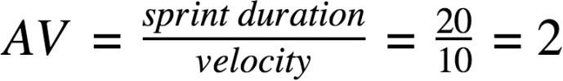

Burndown Chart:

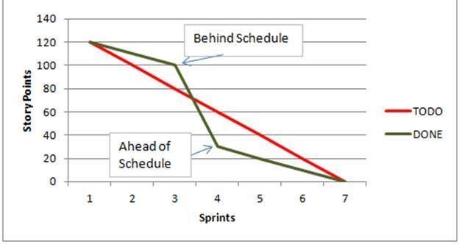

A burn down chart is a graphical representation of work left to do versus time. It is often used in agile software development methodologies such as Scrum. However, burn down charts can be applied to any project containing measurable progress over time.

https://[www.visual-paradigm.com/scrum/scrum-burndown-chart/](http://www.visual-paradigm.com/scrum/scrum-burndown-chart/) https://[www.atlassian.com/agile/tutorials/burndown-charts](http://www.atlassian.com/agile/tutorials/burndown-charts)

Reference:

https://[www.atlassian.com/agile/project-management](http://www.atlassian.com/agile/project-management) https://[www.atlassian.com/agile/tutorials/how-to-do-scrum-with-jira-software](http://www.atlassian.com/agile/tutorials/how-to-do-scrum-with-jira-software) https://[www.atlassian.com/agile/tutorials/epics](http://www.atlassian.com/agile/tutorials/epics) https://[www.atlassian.com/agile/tutorials/sprints](http://www.atlassian.com/agile/tutorials/sprints) https://[www.atlassian.com/agile/project-management/estimation](http://www.atlassian.com/agile/project-management/estimation) https://[www.atlassian.com/agile/tutorials/burndown-charts](http://www.atlassian.com/agile/tutorials/burndown-charts)